Using J2message
On occasion, there are questions pupils need to ask before embarking on a task and as most tasks are completed on Hwb, I would like to draw your attention to J2message as a way of contacting teachers.
Teachers can be messaged directly and we can message back privately too. This is how the screen looks when the tile is selected.
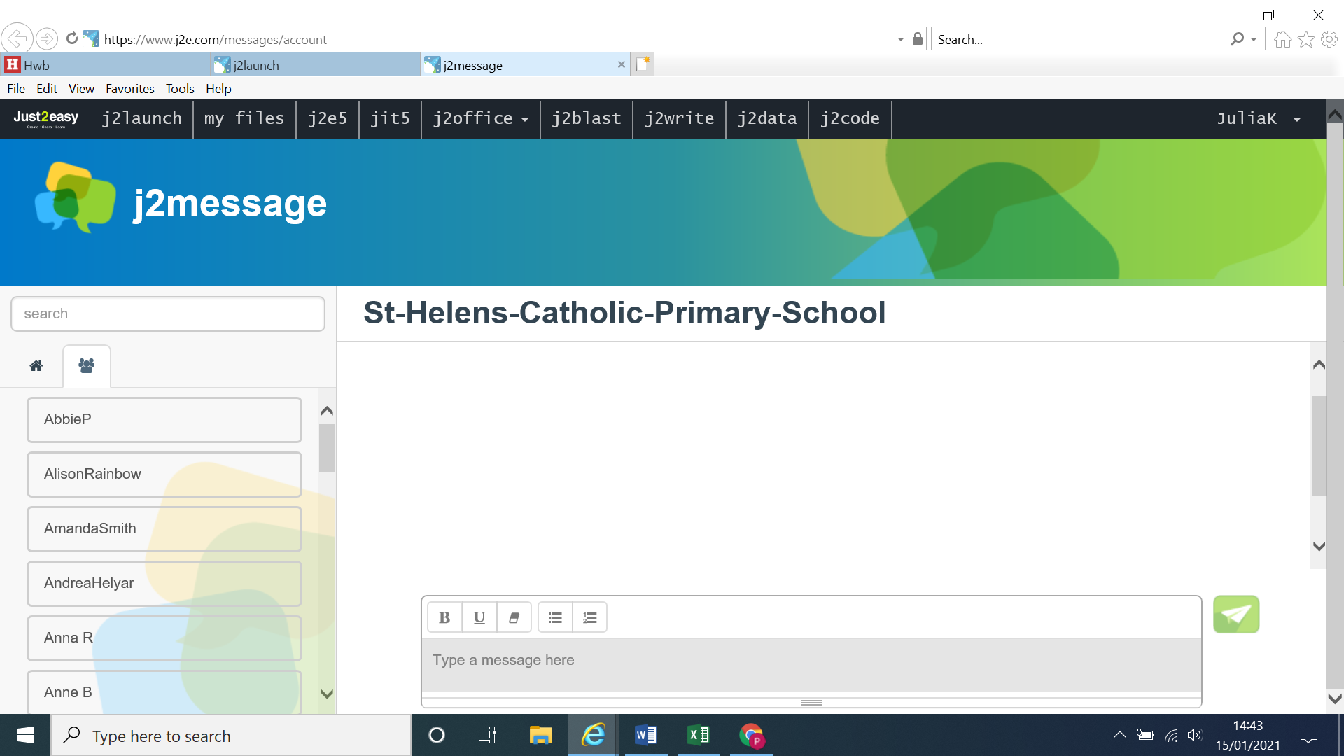
This icon of people can be selected for your child to find the name of their teacher. Every individual in the school is listed alphabetically so you may wish to search for their name instead – for speed.
Once the name is selected it should appear here.

You can now message…… and send.

When your child receives a message it will appear on their dashboard.
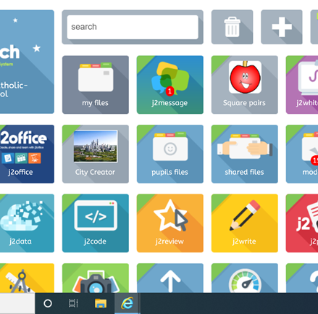
I hope you find this useful

Paula Mansfield
Remote Learning Lead.

