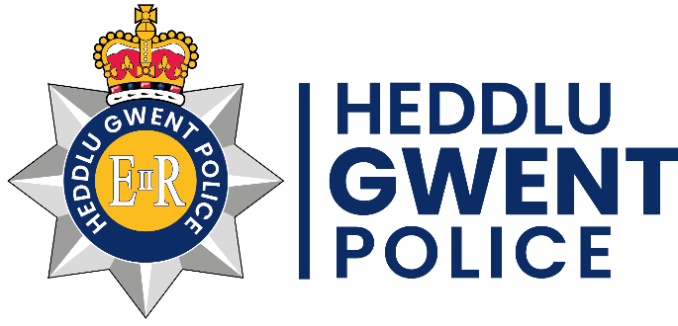 |  | Gwent Police  TRINITY PROTOCOL  (Disability)
The Trinity Protocol is an opportunity for parents/carers, or the individual to provide details about additional needs of a person/themselves, such as Autism, Global Delay, ADHD, Learning Difficulties etc. By sharing information we can be better informed and adapt our response. Those who participate can provide vital information to help officers defuse a threatening situation peacefully, find a missing person or communicate with a witness / victim of crime. The details will be used for the benefit of the person and can be used in any interactions with the Police, so please attach a clear most recent photograph of the person. However, should you change your mind about us having information you can email us and we will remove all the details from the system.

Please fill in as many of the section as you can try and have several copies of recent photographs, both close-up and full length, available as this may help the Police in their search.

If you are concerned about the whereabouts of you’re relative / friend / neighbor, then you MUST call the Police on 101 or visit your local Police Station. If you think that the person is at serious risk of harm call 999.

Tips: Are your “In case of Emergency” (ICE) details up to date on your mobile phone? If not, you should consider updating these. You could include someone who has a copy of this form as one of your chosen ICE contacts.

You can also set up the Find My Phone / Device options on your mobile and provide any login details to someone close to you, or you could add the details on this form below.

You could also download “what3words” app to your phone in case you find yourself somewhere you are unfamiliar with and can share this with someone if you wish. This can be downloaded from your app store:

This form is interactive and must be completed electronically. Upon completion, it must be stored as its own version electronically with an attached recent picture of the person, we will store this on our force system NICHE. Part 1 of the form will provide the Police with valuable information to help locate the missing person as quickly as possible and will provide information to help support and safeguard that person once located.
Part 2 will be fully completed following a missing report. This form should only ever be printed or emailed on the request of a representative of Gwent Police.
Part 1 - (to be completed when it has been identified the individual is at risk of going missing)
Full Name (of person at risk):
Preferred name:
Date of birth: |  |  | Age:
Next of Kin:
Ethnicity:
Gender:
Habits / hobbies including any religious establishments accessed:
Current address:
Postcode:

Details of any Care Order:
Social Worker name & contact Details:
Professionals working with the person:

Previous home / care addresses: | 1.
 | 2.
 | 3.

Previous Missing From Home incident summary:
Previous locations found: (Provide all recent information – List all locations)
Verbal. Non verbal communication (please describe nonverbal communication method)
Significant places of interest to the person:
Special interests and comforters:
Other relevant information:

GP name and address:
Health condition(s):
Medication required:

General description:
Height:
Weight:
Build:
Hair Colour:
Eye Colour / Glasses:
Jewellery:
General Appearance:
Distinguishing features – tattoos/ birth marks/ piercings
what is it / where is it (i.e. ear pierced/wears a gold stud/both ears OR Tattoo/dragon with heart/top of left leg)

Weekly habits and routines – what regularly happens? – Work, weekly shop, visits?
 | Morning | Afternoon | Evening
Monday
Tuesday
Wednesday
Thursday
Friday
Saturday
Sunday

Has the person got a mobile phone / device? |  | Select
Number: |  | Network:
Make |  | Model:
IMEI Number: |  | Mac Address

Does the person have a bus pass: | Select | Provide details  e.g Pass number and Issuer.
Does the person have access to vehicle(s): |  | Provide details  e.g Registration Number/ Driver etc.
Does the person have a passport: | Select | Provide details  e.g Passport number and Issuing Country.

Does the person have Social Media Accounts (Provide Details): |  |  | Select
Social media site: |  | Username: |  | Do you have access to the password?
Social media site: |  | Username: |  | Do you have access to the password?
Social media site: |  | Username: |  | Do you have access to the password?
Social media site: |  | Username: |  | Do you have access to the password?
Social media site: |  | Username: |  | Do you have access to the password?

How best can we create a positive police interaction for the person named? | No sirens, hi-vis jackets etc.
Calming strategies that work | what is the best way you know?
Fears such as Balloons, loud sounds etc.
Dislikes and Possible Triggers
Assistant Aids used | Such as walking or communication aids. Anything that is used to help
Regimented Behaviour | Clothing style, or something that has to be done before they can move on
Favourite Hiding Place in the Home
Favourite place to go in your area or village | Parks, lakes, shops etc.
Independent activities | Catch a bus, pay for goods in a shop, walk a mile

Completed in advance by:
Relationship to person:
Contact Number:
Date:
Any other relevant information:

Consent
Do you consent to information being provided to the media, or to being used on social media to support the search?
Do you consent to information on this form by yourself being shared to support in locating your whereabouts with:
Police: | Yes | No
Media (Newspapers, TV, Radio etc): | Yes | No
Social Media (Facebook, Twitter etc): | Yes | No
Other Parties (your local Council, ambulance services etc): | Yes | No

Do you consent to your medical information being released if required? (Yes/No):

Signature:
Print Name: |  | Date:

Trinity Protocol has been jointly set up with Trinity Fields School and Resource Centre.

It is the responsibility of the agency completing and the recipient to protect the information from theft and compromise. This form and the information contained in it must be securely stored.

