**How to find a spelling list on**

**HWB – J2blast.**

Log into HWB using your login cards to help. Go to Just2Easy and click onto the J2bast tile.

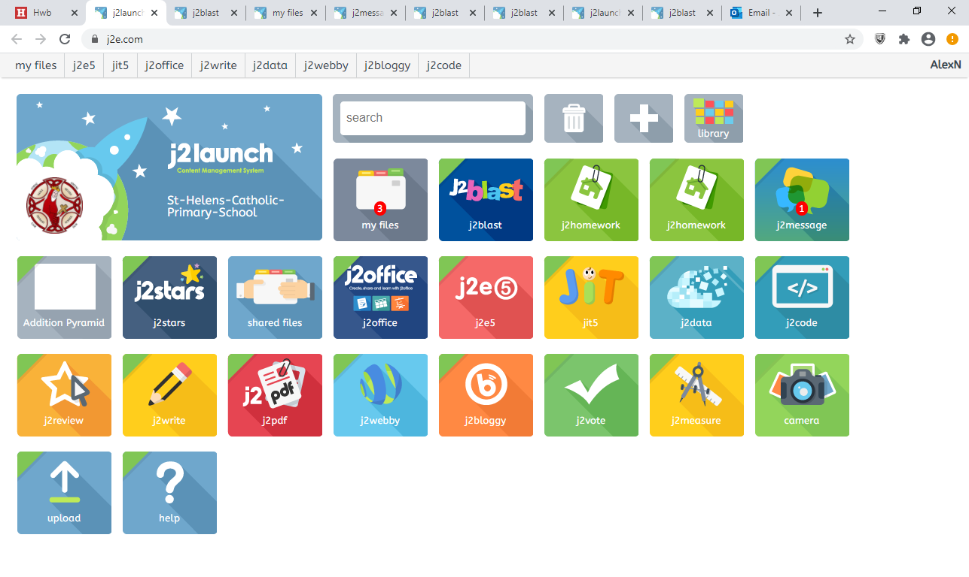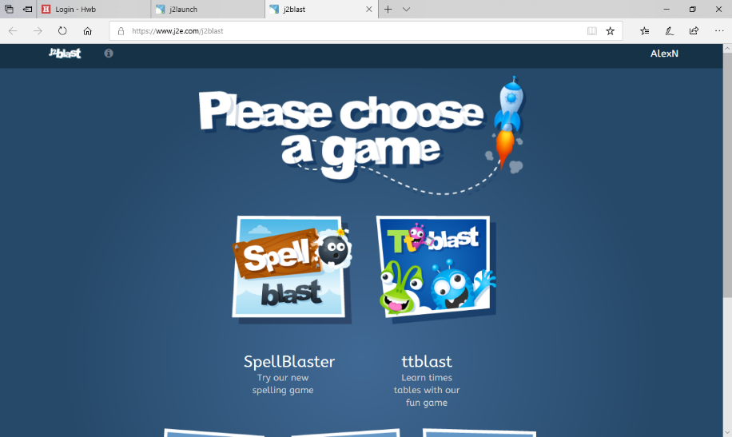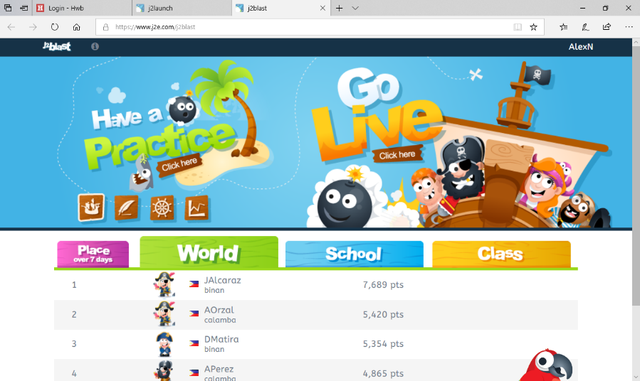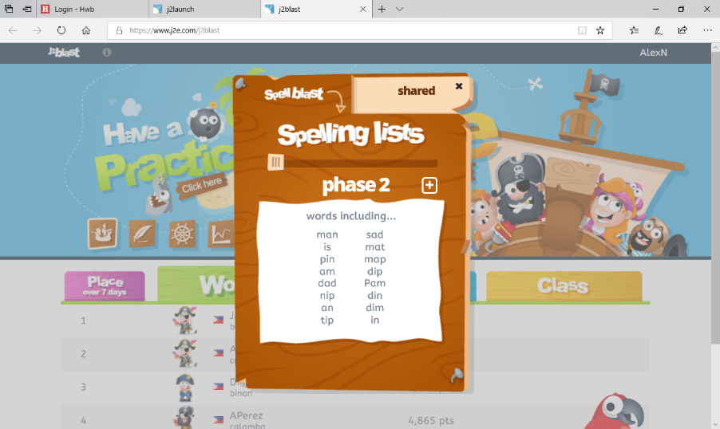

Lastly click on the shared tab where you will find the spelling list to practise.

Click on click here under the words have a practice.

Next, click on spell blast.